
JOB DESCRIPTION
Mechanical Engineer Shall
- Develop, design and plan Mechanical projects and assigned multi-discipline projects to ensure the optimum reliability, availability and technical integrity of plant assets
- Provide support in procurement of like for like and obsolete equipment replacement covered under TSR's to support plant integrity and reliability.
- Plan & prepare the design, engineering, procurement and construction packages for Mechanical projects and assigned multi-discipline SPCs & projects to maintain and enhance HSSE, Integrity, Reliability and Profitability.
- Provide technical advice and assistance to the design office and construction team to support development of MPCs, installation, commissioning and close out of projects.
- Develop cost estimates for projects to support project development.
- Develop project execution strategies for Mechanical projects and assigned multi-discipline SPCs and projects to achieve project objectives.
- Provide MCP with technical support by developing specification for project material and reviewing technical/commercial quotes to ensure materials are acquired as per specifications.
- Provide MCP with technical support by providing / reviewing scope of work and monitoring execution of contract to ensure competent contract services are acquired and executed.
- Advise Mechanical Project Engineering services to the business units and maintains good communication with projects leaders and end users to ensure critical areas of concern are addressed.
- Coordinate assigned multi-discipline projects, promotes safe working practices and develops technically sound and cost effective mechanical engineering solutions

QUALIFICATION
- B.Sc. Degree in Mechanical engineering or equivalent.
- Minimum of 6 years’ experience in projects engineering, design and project management in the oil or petrochemical industry.
- Very good English language skills and competent in the use of PC applications (MS Office suite or equivalent).
- Engineering Standard Practice and Safety in Design.
- Principles and Practices of Mechanical Engineering.
- Analytical thinking
- Customer Service Orientation
- Teamwork

Contact

Send you Cv’s to job@mazco.com.sa

Or

Post Box: 2486, Dammam 31451,
KINGDOM OF SAUDI ARABIA.
Tell: +966 3 8260080 EXT: 31
Fax : +966 3 8266618
Website::www.mazco.com.sa

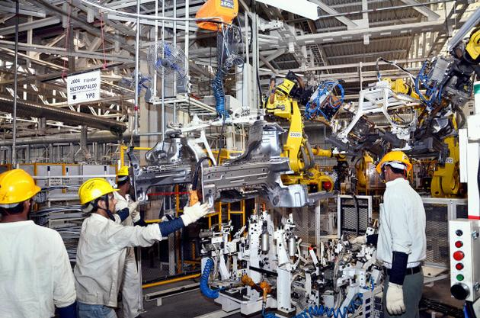
Mechanical Engineer

